**The Matrix City**

Ahmed Hussein often goes to his Friend Osama who lives in the Matrix City, the Matrix City is designed to have square shaped Buildings and streets and avenues crossing between them horizontally and vertically making it to look like a Matrix like the figure below.

In the Matrix City the Sun only rises in the South East (Strange, isn’t it?), so Ahmed can only walk with his back to the Sun facing either the North or the East only *(Because Ahmed Hussein Skin is very sensitive to the Sun Rays)*, we know that Osama’s House is always on his North East Side.

Unfortunately Ahmed gets boring easily so every time he visits Osama he chooses a different path to walk than he had chosen before and he never walks the same path twice, after that he dumps him and finds another friend to visit, the figure below explains the first test case.

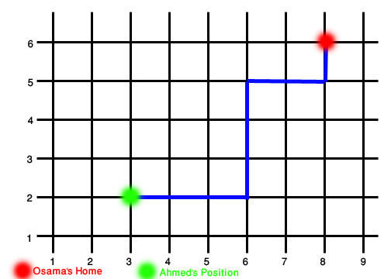

***Example of one of many Possible Routes***

Input:

You're given the number of test case (t) , current Position of Ahmed (x1, y1) and the Position of Osama's House(x2,y2) where (**0<t<100 & 0<x2-x1<10 & 0<y2-y1<10 ).**

Output:

Print the number of different paths/routes Ahmed could choose before he could get bored from visiting Osama again in the Format showed below.

Sample Input:

2

3 2 8 6

1 1 3 2

Sample Output:

Case 1: 126

Case 2: 3